Week 5 right up

Q1)

https://github.com/Carciax/EEE3088F-Project-CKR

Q2)

i) going to put populate zero ohm resistance in series with each modular component and unpopulated zero ohm resistor over each modular component allowing me to bypass each modular component by desoldering the populated 0 ohm resistor and resoldering the unpopulated resistor. I'm also going to put lots of test points which are going to be through holes which give me the ability to connect wires later on. I will also put jumpers next to the battery and at the three Volt three out and ground allowing us to connect an external 3.3 volts either in place of the battery or just to the main circuit.

ii) I will ensure to use the correct size track to the appropriate current rating for each track to protect against track damage.

I will also make the ground track thick as well as making ground its own level on the board.

iii) I will provide other options to replace components or go and buy the components from other shops and solder them on. I will also ensure to use components with large quantities of stock decreasing the chance of the component running out.

iv) I will make the circuit as modular as possible allowing for changes to the circuit as well as providing lots of available connection points to make modifications post PCB development.

Q3

Q3 Sensing Subsystem Failure Management [2] Include your prior text and note any changes made - you can show changes via text colour or separate section/itemised errata / any way that keeps the report neat and makes it obvious to a reader what is new/different

Q4 Microcontroller interfacing Failure Management [2] Include your prior text and note any changes made - you can show changes via text colour or separate section/itemised errata / any way that keeps the report neat and makes it obvious to a reader what is new/different

I have made a few changes to some of the resistance values as they were wrong. I have added test points throughout the circuit which will provide us with opportunities to test as well as solder on wires if we need. I have also added unpopulated and populated 0 ohm resistors over each modular component so that we can remove and add modular components as we want.

Q6 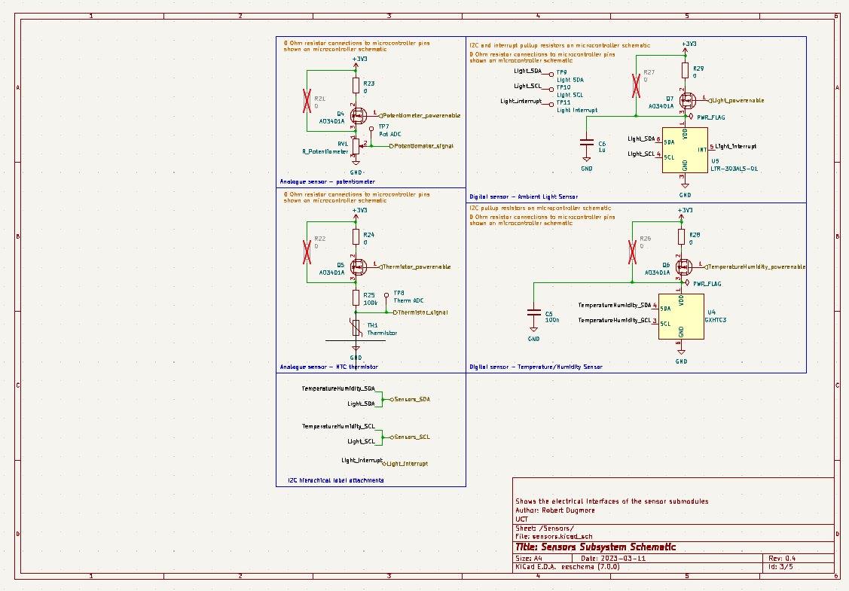

If no changes made say this is the case

Q7) 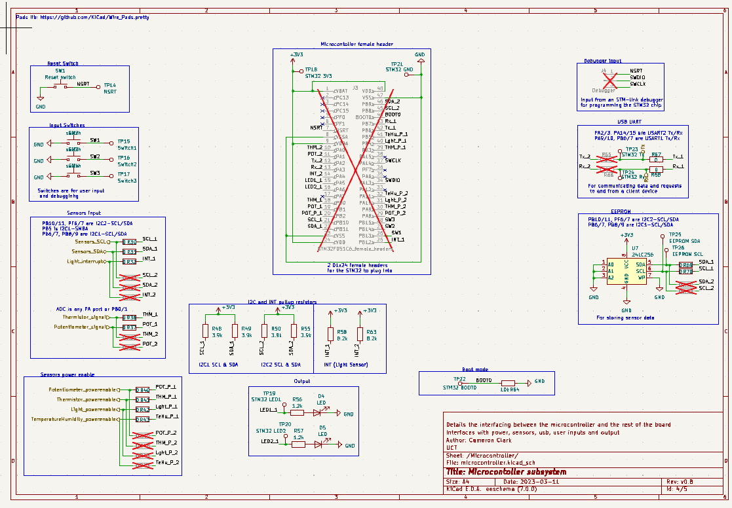

If no changes made say this is the case

Q8 Updated ERCs [2] Insert what ERCs you used and a screenshot showing the report with no errors

Q9 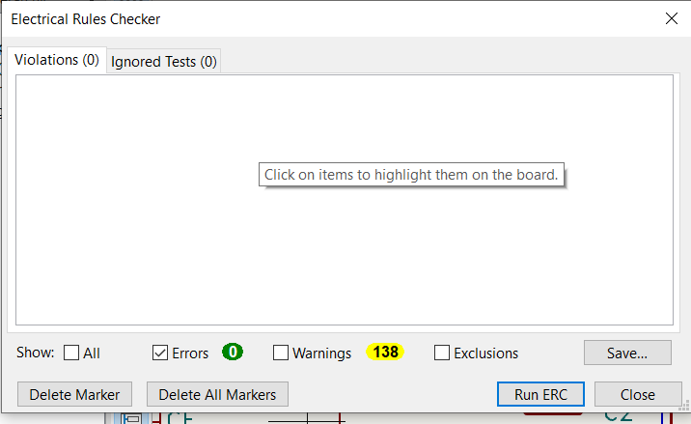

Q10 Updated BOM [5] Insert a link to your updated BOM in your git repository. This should be a csv or excel file that you exported from KiCAD that includes: Component name, Component Count, Component $ value, Component JLC part number Also include a budget total here in the PDF

Q11 PCB [15] ● Insert screenshots showing each layer of your PCB. The layout and routing should be visible on each layer of the board. For example, for the top layer show layout and routing, bottom layer could just show the routing, ● Show ground planes and silk screen(s) separately. These should be clearly visible, you can turn off the other layers to make it more clear. ● Label each image ● Include a screenshot of a 3D view of the PCB ● Indicated where in your gitrepo the gerber files are